
Order Of Service

Singing: Psalm 118—CW page 108

Reading: Psalm 149

Opening Hymn: TLH 517

Reading: II Peter 1:16-21

Request Hymn: CW Supplement 749

Reading: Luke 22:63-71

Sermon Hymn: TLH 514

Sermon Text: Song Of Solomon 3:1

Seeking But Not Finding # 1

Prayer

The Apostles’ Creed, TLH page 12

Holy Communion

The Lord's Prayer

The Blessing

Closing Hymn: TLH 45

* * * * * * * * * * *

Bible Study: Lambs: Luke 22:42; Thy Will Be Done
Sheep: Proverbs 9:13-18; Your Choice

Seeking By Night

Water
Of
Life
17 April 2016

W A T E R O F L I F E

Independent Christian Church—Conservative Lutheran Doctrine

Worship Service: 9:30 a.m. Bible Study: 10:45 a.m.

Larry Cooper, Pastor E-Mail address:
111 N. Ridge Road lcooper@wateroflife.cc
Coon Valley, WI 54623 Web Site:
Phone: (608) 452-2105 www.wateroflife.cc

* * * * * * * * * * * * * * * * * * * * * * * * * * *

Sermon Text: Song Of Solomon 3:1

Seeking But Not Finding # 1

* * * * * * * * * * * * * * * * * * * * * * * * * * *

Song of Solomon 3:1 By night on my bed I sought him whom my soul loveth: I sought him, but I found him not.

In the parable recorded for us by the Holy Spirit in Matthew 13:44, the Son of God takes us out into a farmer’s field. “Again, the kingdom of heaven is like unto treasure hid in a field; the which when a man hath found, he hideth, and for joy thereof goeth and selleth all that he hath, and buyeth that field.”

The oddity here is that the farmer didn’t really find the treasure. When he went out to plow in his field that was most likely the last thing he expected. The truth is that the treasure really found the farmer. And we are reminded of the words of Christ recorded in Isaiah 65:1: “I am found of them that sought me not.”

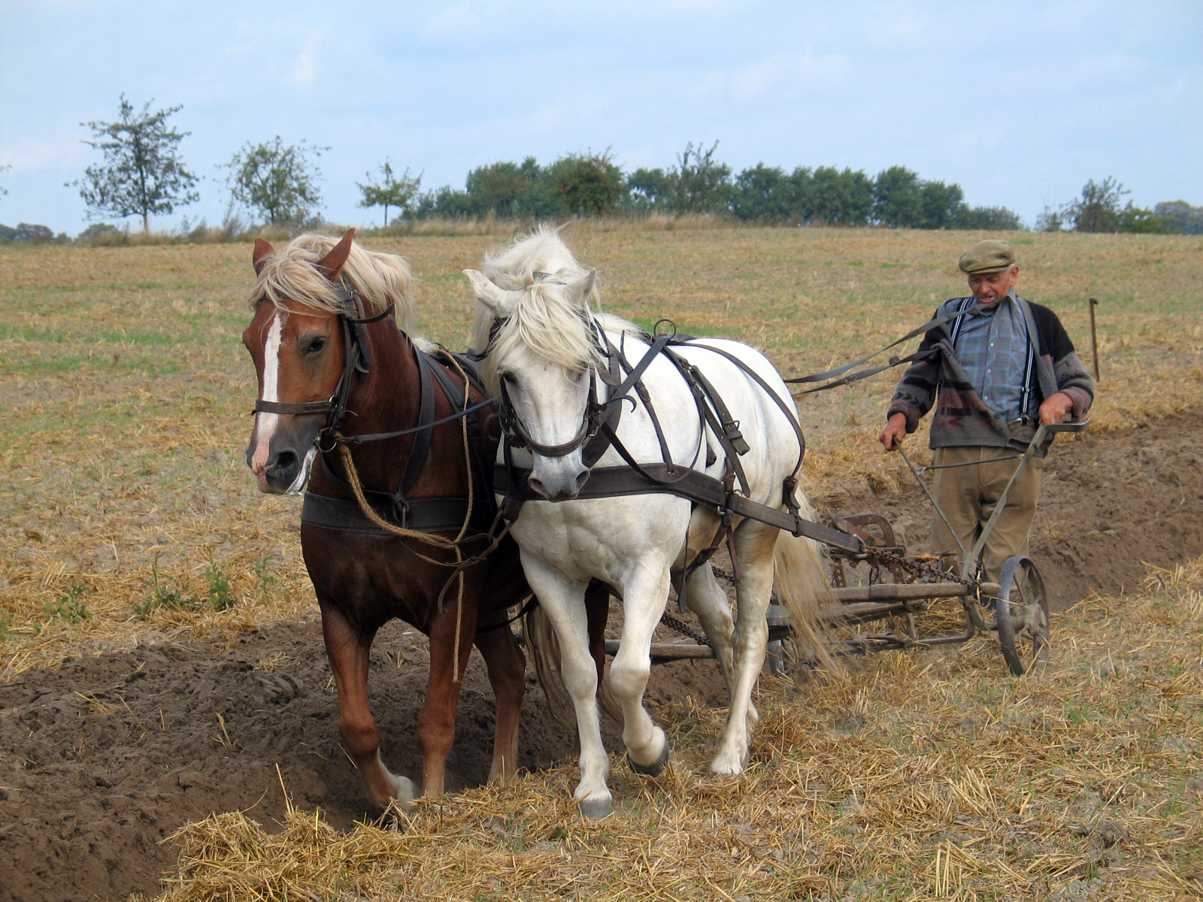

By sharp contrast, here in Song of Solomon 3:1 we have the Bride searching for her loved one. But she doesn’t find him. “By night on my bed I sought him whom my soul loveth: I sought him, but I found him not.” This is one of the many “night scenes” recorded by the Holy Spirit in Scripture.

This is not an unusual experience for an elect child of God. Truth be told, there are times in the life of the Bride of Christ when her Bridegroom seems to be hiding from her.

Here, among other things, we think of I Peter 1:6-7. :6 Wherein ye greatly rejoice, though now for a season, if need be, ye are in heaviness through manifold temptations: :7 That the trial of your faith, being much more precious than of gold that perisheth, though it be tried with fire, might be found unto praise and honour and glory at the appearing of Jesus Christ:

